SVCHS UDS Clinical Quality Measures
Provider Scores
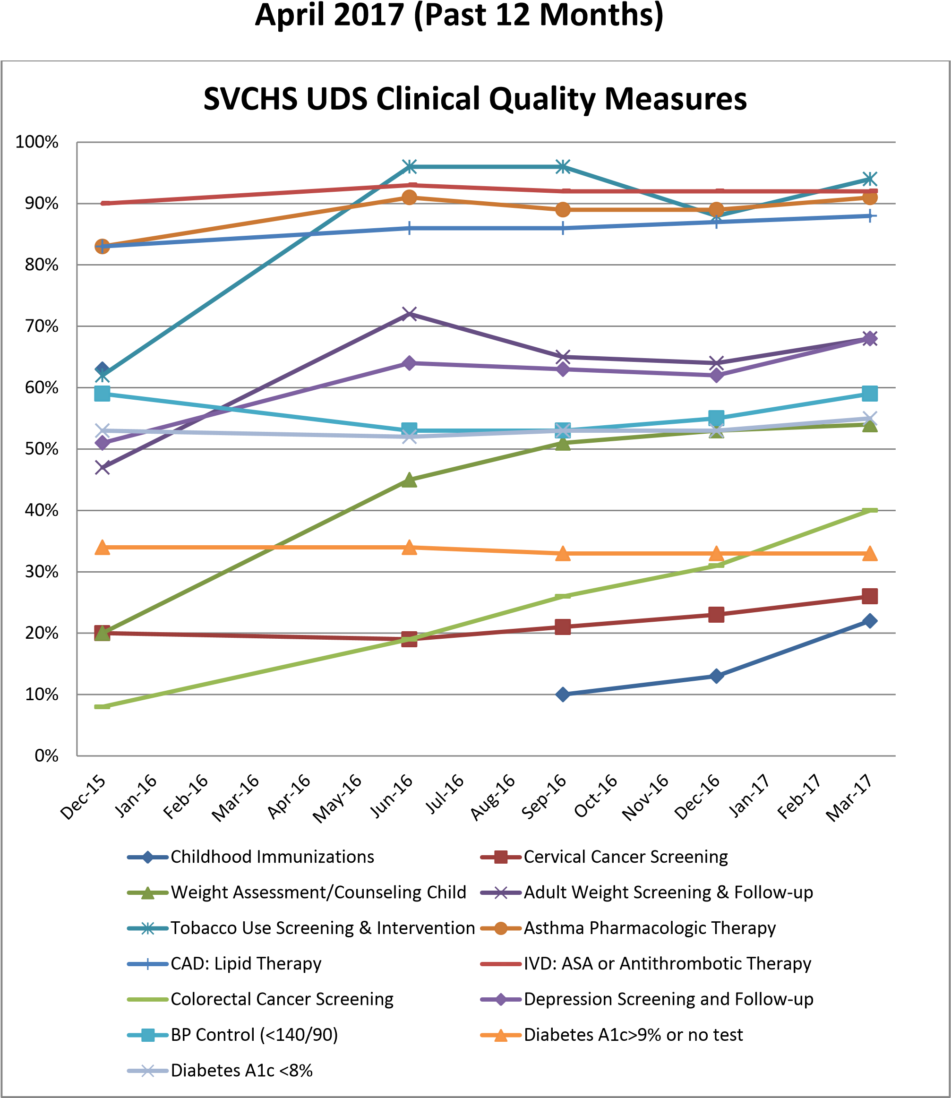

%
0

%
10

%
20

%
30

40
%

%
50

%
60

70
%

80
%

90
%

Andrews

Croteau

Moore

Blackburn

Chapman

Fullen

Branham

Wilson

Ortiz

Jackson

Bresowar

Adult Weight Assess & Counsel Provider Score

April 2017 (Past 12 Months)

0
%

%
10

20
%

%
30

%
40

%
50

%
60

%
70

Wilson

Croteau

Ortiz

Fullen

Jackson

Chapman

Branham

Moore

Andrews

Bresowar

Blackburn

Blood Pressure Control Provider Score

April 2017 (Past 12 Months)

0
%

10
%

%
20

%
30

%
40

%
50

%
60

Croteau

Chapman

Branham

Andrews

Ortiz

Wilson

Bresowar

Fullen

Blackburn

Jackson

Moore

Breast Cancer Screening Provider Score

April 2017 (Past 12 Months)

%
0

10
%

%
20

%
30

%
40

%
50

%
60

Croteau

Chapman

Branham

Andrews

Ortiz

Wilson

Bresowar

Fullen

Blackburn

Jackson

Moore

Cervical Cancer Screening Provider Score

April 2017 (Past 12 Months)

0
%

10
%

%
20

%
30

%
40

%
50

%
60

%
70

Moore

Blackburn

Branham

Fullen

Wilson

Bresowar

Ortiz

Chapman

Bradley

Jackson

Bates

Child Weight Assess & Counsel Provider Score

April 2017 (Past 12 Months)

%
0

%
10

%
20

%
30

%
40

%
50

%
60

70
%

%
80

Croteau

Wilson

Branham

Chapman

Fullen

Ortiz

Andrews

Blackburn

Bresowar

Moore

Jackson

Colorectal Cancer Screening Provider Score

April 2017 (Past 12 Months)

%
0

%
10

%
20

30
%

%
40

%
50

%
60

%
70

%
80

%
90

Blackburn

Bradley

Chapman

Croteau

Moore

Bresowar

Jackson

Ortiz

Wilson

Branham

Fullen

Andrews

Bates

Depression Screening & Follow Up Score

April 2017 (Past 12 Months)

0
%

%
10

20
%

%
30

%
40

%
50

%
60

%
70

Croteau

Ortiz

Chapman

Andrews

Fullen

Wilson

Branham

Moore

Blackburn

Jackson

Bresowar

Diabetes Control A1c <8% Score

April 2017 (Past 12 Months)

0
%

10
%

%
20

%
30

%
40

%
50

%
60

Croteau

Ortiz

Chapman

Andrews

Wilson

Branham

Jackson

Fullen

Moore

Bresowar

Blackburn

Diabetes Poor Control A1c >9% or No Test

April 2017 (Past 12 Months) Score

%
75

%
80

85
%

90
%

95
%

100
%

Andrews

Jackson

Moore

Fullen

Ortiz

Blackburn

Bresowar

Croteau

Wilson

Chapman

Branham

Bates

Tobacco Use Screening & Intervention

April 2017 (Past 12 Months) Score

